Question # 1 of 10 ( Start time: 10:18:35 PM ) Total Marks: 1
Spiral model has _____________ dimensions.
Select correct option:
2
3
4
None of the above
Question # 2 of 10 ( Start time: 10:19:13 PM ) Total Marks: 1
Fred Brook is a famous software engineer who wrote a great book related to software engineering named _______________.
Select correct option:
A Mythical Man Month
A Mathematical Man
Software Methodologies
None of the above
Question # 3 of 10 ( Start time: 10:19:46 PM ) Total Marks: 1
SEI stands for _________________
Select correct option:
Software Engineering Institute
Software Electric Institute
Software Electronics Institute
System Engineering Institute
Question # 4 of 10 ( Start time: 10:20:29 PM ) Total Marks: 1
In ____________________ team organization, there is no permanent leader rather there are task coordinators.
Select correct option:
Controlled Decentralized
Democratic Decentralized
Controlled Centralized
Synchronous paradigm
Question # 5 of 10 ( Start time: 10:21:27 PM ) Total Marks: 1
Effective software project management focuses on the four P’s: These are
Select correct option:
People , Product , Process , Problem
People , Product , Process , Project
People , Passion , Process , Project
People , Passion , Planning , Project
Question # 6 of 10 ( Start time: 10:22:08 PM ) Total Marks: 1
Capability Maturity Model has been developed by System Engineering Institute.
Select correct option:
System Engineering Institute
Software Engineering Institute
SIS Engineering Institute
System and Technology Institute
Question # 7 of 10 ( Start time: 10:22:47 PM ) Total Marks: 1
Build and fix model is good for _______ programs that do not require _____________.
Select correct option:
large , testing
short , maintenance
complex , QA
small, testing
Question # 8 of 10 ( Start time: 10:24:18 PM ) Total Marks: 1
The important feature of extreme programming is the concept of __________________.
Select correct option:
Feedback
Risk assessment
Pair programming
Requirement elicitation
Question # 9 of 10 ( Start time: 10:25:11 PM ) Total Marks: 1
MOI model of leadership stands for
Select correct option:
Motivation , Operationalize ,Integration
Misunderstanding , Object, Ideas
Motivation , Organization , Innovation
Miscommunication , Organization, Invention
Question # 10 of 10 ( Start time: 10:25:57 PM ) Total Marks: 1
After passing through all the stages of the software development when we deploy the new system at the user side that stage is called ____________.
Select correct option:
integration
development
installation
status quo

Question # 1 of 10 ( Start time: 06:54:38 PM ) Total Marks: 1
A mock up application is developed in ______________ model to get user feedback.
Select correct option:
waterfall
object oriented
fountain
rapid prototype
Question # 2 of 10 ( Start time: 06:55:07 PM ) Total Marks: 1
Software Engineering is the set of __________and ___________to develop software.
Select correct option:
classes ,objects
languages , processes
processes, tools
tools, objects
Question # 3 of 10 ( Start time: 10:11:04 PM ) Total Marks: 1
_____________ http://onlinevu.blogspot.com/ is the ability to encourage people to create and feel creative.
Select correct option:
Organization
Motivation
Innovation
Managerial Identity
Question # 4 of 10 ( Start time: 10:12:01 PM ) Total Marks: 1
Caper Jones is famous researcher in the field of ___________ who made a company named Software Productivity Research
Select correct option:
Biology
Chemistry
Mathematics
Software Engineering
Question # 5 of 10 ( Start time: 10:12:39 PM ) Total Marks: 1
eXtreme http://onlinevu.blogspot.com/ programming model is the concept of _____________programming.
Select correct option:
structural
sequential
pair
event driven
Question # 6 of 10 ( Start time: 10:13:51 PM ) Total Marks: 1
______________ model has a major drawback in that the delivered product may not fulfill the customer's requirements.
Select correct option:
Waterfall
Build and Fix
Prototyping
Integrated waterfall and prototyping
Question # 7 of 10 ( Start time: 10:14:24 PM ) Total Marks: 1
_______________ procedures include QA activities, design and code reviews, and status meetings.
Select correct option http://onlinevu.blogspot.com/:
Informal, interpersonal
Formal, interpersonal
Informal, interpersonal
Controlled centralized
Question # 8 of 10 ( Start time: 10:14:51 PM ) Total Marks: 1
___________________ is an Object Oriented model.
Select correct option:
Spiral
Water fall
Incremental
Fountain
Question # 9 of 10 ( Start time: 10:15:23 PM ) Total Marks: 1
Task coordinators are appointed for short period of time in ______________ organization team structure.
Select correct option:
controlled centralized
democratic decentralized
controlled decentralized
formal impersonal approach
Question # 10 of 10 ( Start time: 10:15:51 PM ) Total Marks: 1
Effective project management focuses on 4 P’s. http://onlinevu.blogspot.com/ These are _________, _________, _________, and ___________.
Select correct option:
procedure, progress, public, practice
people, product, process, project
performance, practice, people, progress
popularity, productivity, possession, policy

Question # 1 of 10 ( Start time: 12:30:43 PM ) Total Marks: 1
Capability Maturity Model has been developed by System Engineering Institute.
Select correct option:
System Engineering Institute
Software Engineering Institute
SIS Engineering Institute
System and Technology Institute
Question # 2 of 10 ( Start time: 12:18:17 PM ) Total Marks: 1
Continuous process improvement is enabled by __________ feedback from the __________.
Select correct option:
analytical , user
mathematical, user http://onlinevu.blogspot.com/
logical, process
qualitative , process
Question # 3 of 10 ( Start time: 12:32:28 PM ) Total Marks: 1
_______________ http://onlinevu.blogspot.com/ procedures include QA activities, design and code reviews, and status meetings.
Select correct option:
Informal, interpersonal
Formal, interpersonal
Informal, interpersonal
Controlled centralized
Question # 4 of 10 ( Start time: 12:34:00 PM ) Total Marks: 1
MOI model of leadership was developed by http://onlinevu.blogspot.com/ __________.
Select correct option:
Weinberg
Newton
Don Carlos
Edison
Question # 5 of 10 ( Start time: 12:35:12 PM ) Total Marks: 1
Caper Jones divided software related activities into _____________ different categories.
Select correct option:
35
40
20
25
Question # 6 of 10 ( Start time: 12:40:49 PM ) Total Marks: 1
If a software developer is going to develop software for a nuclear reactor which factor(s) will be more important?
Select correct option:
cost effectiveness
performance
reliability
both performance and reliability
Question # 7 of 10 ( Start time: 12:41:50 PM ) Total Marks: 1
Each process defines certain deliverables known as the http://onlinevu.blogspot.com/ _____________.
Select correct option:
work products
software
final product
items
Question # 8 of 10 ( Start time: 12:42:26 PM ) Total Marks: 1
At Level-1 organizations follow _________processes.
Select correct option:
linear
ad hoc
object oriented
complex
Question # 9 of 10 ( Start time: 12:43:09 PM ) Total Marks: 1
eXtreme programming model is the concept of _____________programming.
Select correct option:
structural
sequential
pair
event driven
Question # 7 of 10 ( Start time: 12:21:04 PM ) Total Marks: 1
Performance is inversely http://onlinevu.blogspot.com/ proportional to the _________________.
Select correct option:
number of coordinators
amount of communication
amount of time
number of leaders

Question # 1 of 10 ( Start time: 12:15:06 PM ) Total Marks: 1
___________________ is an Object Oriented model.
Select correct option:
Spiral
Water fall
Incremental
Fountain
Question # 2 of 10 ( Start time: 12:16:41 PM ) Total Marks: 1
QA is an activity performed ___________ of the software development.
Select correct option:
at the initial stage
at the final stage
throughout
at the middle
Question # 3 of 10 ( Start time: 12:17:42 PM ) Total Marks: 1
Each process defines certain deliverables known as the http://onlinevu.blogspot.com/ _____________.
Select correct option:
work products
software
final product
items
Question # 4 of 10 ( Start time: 12:18:17 PM ) Total Marks: 1
Continuous process improvement is enabled by __________ feedback from the __________.
Select correct option:
analytical , user
mathematical, user
logical, process
qualitative , process
Question # 5 of 10 ( Start time: 12:18:57 PM ) Total Marks: 1
http://onlinevu.blogspot.com/ Vision phase in a software process focuses on __________.
Select correct option:
What
Why not confirm
How
Change
Question # 6 of 10 ( Start time: 12:19:42 PM ) Total Marks: 1
Construction activities are directly related to the _____________ of the software.
Select correct option:
installation
risk analysis
development
debugging
Question # 7 of 10 ( Start time: 12:21:04 PM ) Total Marks: 1
Performance is inversely proportional to the _________________.
Select correct option:
number of coordinators
amount of communication
amount of time
number of leaders
Question # 8 of 10 ( Start time: 12:21:37 PM ) Total Marks: 1
____________ http://onlinevu.blogspot.com/ activity is performed throughout software production
Select correct option:
Maintenance
Development
Analysis
Quality Assurance
Question # 9 of 10 ( Start time: 12:22:20 PM ) Total Marks: 1
In software development ____________________ is performed at the end of each phase.
Select correct option:
Verification
Validation
identification http://onlinevu.blogspot.com/
Accreditation
Question # 10 of 10 ( Start time: 12:23:09 PM ) Total Marks: 1
Rapid application development is another form of _________________.
Select correct option:
Incremental model
Prototyping model
Linear Sequential model
None of the above

My today quiz of 11 may
1. _______________ model is developed keeping in mind the element of risk in the development of software
ü spiral
ü rad
ü incremental
ü synchornize and stablize
2. _____________dimension of Spiral model represents the cumulative cost to date
ü radial
ü angular
ü horizontal
ü circular
3. In Capability Maturity Model (CMM), ___________ performs optimization.
ü level1
ü level 2
ü level3
ü level5
4. In ________ model user feedback is received very quickly because product is delivered in small versions.
ü waterfall
ü spiral
ü incremental
ü ibject oriented
5.In ________________ model the product is developed without any proper design and specifications.
ü waterfall
ü buil and fix
ü prototyping
ü none of them
6The important feature of extreme programming is the concept of __________________.
ü feedback
ü risk assessment
ü pair programing
ü requirmnts elicitations
7.__________is the ability to encourage technical people to produce to their best.
ü improvemnet
ü motivation
ü innovation
ü creation
8.process to improve the chances of success.
ü 3
ü 4
ü 5
ü 8
9.If a software developer is going to develop software for a nuclear reactor which factor(s) will be more important?
ü cost effective
ü perfomance
ü reliability
ü both b and c
10.Capability Maturity Model (CMM) has __________ levels.
ü 4
ü 5
ü 3
ü 2

My previous quizz
1.By default every organization is working at _______________
level 1
level 0
level 3
level 4
2.Software Engineering is the set of __________and ___________to develop software.
languages , processes
classes ,objects
processes, tools
tools, objects
3._______________model is a haphazard type of software development activity.
Water fall
incremental
prototyping
build and fix
4._____________________ phase in a software process focuses on change.
vision
maintanince
defination
development
5,COCOMO is the classic LOC cost-estimation formula and used thousand delivered
source instructions (KDSI) as his ……… of size.
LOC
milestone
unit
none of given
6._______________ deadline is one of the reasons of project failure.
achieveable
feasible
unrealistic
realistic
7.___________ model is very sensitive to the risk.
spiral
waterfall
incremental
RAD
8.MOI model of leadership stands for
Motivation , Operationalize ,Integration
Misunderstanding , Object, Ideas
Motivation , Organization , Innovation
Miscommunication , Organization, Invention
9. __________is the ability to encourage technical people to produce to their best.
improvement
motivation
innovation
creation
10.____________activity is performed throughout software production
maintaince
develpomentt
anylsis
quality assurance

This is my 1st quiz of cs605
- Software process and product quality are controlled at ________.
level 1
initial level
level-4
level-3
2. MOI model of leadership stands for
Motivation , Operationalize ,Integration
Misunderstanding , Object, Ideas
Motivation , Organization , Innovation
Miscommunication , Organization, Invention
3. Spiral model has _____________ dimensions.
2
3
4
None of the above
4. The _____________ model is used to overcome issues related to understanding and capturing of user requirements.
Rapid Prototyping
Water fall
Build and Fix
None of the above
5. QA is an activity performed ___________ of the software development.
at the initial stage
at the final stage
throughout
at the middle
6. ___________________ is an Object Oriented model.
Spiral
Water fall
Incremental
Fountain
7. _____________ the ability to encourage people to create and feel creative.
Organization
Motivation
Innovation
Managerial Identity
8. Software has very close relationship
Biology
Physics
chemistry
Economics
9. Caper Jones divided software related activities into _____________ different categories.
35
40
20
25
10._________________major drawback in that the delivered product may not fulfill the customer requirement.
Waterfall
build-and fix
Prototyping
Integrated Waterfall and Prototyping

Some helping Mcqz for Quiz
1.For a software the total number of requirements are equal to ________.
1 Functional requirements
2 Non functional requirements
3 Functional requirements + non functional requirements-------
4 None of the given options
2._______ is the measure of how many defects are removed by the quality assurance processes before the product is shipped for operation.
1 Removal Deficiency
2 Defect removal efficiency------
3 Bug Report
4 Bug Tracking Algorithm
3.Extent to which access to software or data by unauthorized persons can be controlled, is called _______.
1 None of given
2 Efficiency
3 Reliability
4 Integrity-------
4.A _____ provides a quantitative value of some attribute of a process or a product.
1 Metric
2 Measure-----
3 Function point
4 Plan
5.Effort required to test a program to ensure that it performs its intended function ________.
1 Testability-----
2 Bug fixing
3 Debugging
4 Security
6.We need to employ some statistical techniques and plot the results __________. These are known as statistical control techniques.
1 Graphically-----
2 Automatically
3 Manually
4 Personally
7.________ technique was initially developed for manufacturing processes in the 1920’s by Walter Shewart.
1 Upper Control Line
2 Contorl chart------
3 CMP
4 Quality
8.Control charts are of following two types:
1 Moving range control charts and Individual control charts----
2 Moving range control charts and statical control charts
3 Individual control charts and statical control charts
4 None of the given options
9.The extent to which a program can be reused in other applications is called ________.
1 Reliability
2 Performance
3 Usability
4 Reusability-----
10.Quality can be measured if we measure the _____ of the product.
1 correctness
2 maintainability
3 integrity and usability
4 All of the given options-----
11.The amount of "computing resources", required by a program to perform its function is __________.
1 Efficiency-----
2 Integrity
3 Reliability
4 None of given
12.Defects per function points is a ________.
1 Measure
2 Metric-------
3 Quality attribute
4 Process
13.Extent to which access to software or data by unauthorized persons can be controlled, is called ________.
1 None of given
2 Efficiency
3 Reliability
4 Integrity -----
14.Defect removal efficiency is calculated as: Where E = errors found before delivery D = errors found after delivery (typically within the first year of operation)
1 DRE = E/(E+D)-----
2 DRE = E + D
3 DRE = E + D/E
4 DRE = E/D - E
15.In context of "Individual control chart", if a single metrics value lies outside UNPL, it means that:
1 The process has been matured
2 The process is not mature yet
3 Process is out of control-----
4 Process is within control
16.In context of moving range and individual control charts, UNPL stands for:
1 Universal Natural Process Line
2 Universal Natural Process Limit
3 Upper Natural Process Limit-----
4 Upper Natural Process Line
17.When more than one users interpret the same requirement in different ways then we can say that the requirement is:
1 None of the given
2 Incomplete
3 Ambiguous-----
4 Incorrect
18.Identify the most appropriate statement:
1 The quality of the software specification is of extreme importance.-----
2 The non functional requirements can be skipped.
3 The non functional requirements does not impact the quality of product.
4 None of the given options.
19.Which of the following is not TRUE about "Error Tracking"?
1 Error tracking can be used to estimate the progress of the project
2 We track errors in work products to assess the status of a project.-----
3 During "Error Tracking", we may also need the historical data from similar projects.
4 All of the given
20.CPM stands for:
1 Critical Project Measure
2 Critical Path Method-----
3 Common Project Measure
4 Critical Planning Model
21.The boundary time defines the following parameter(s) for a project:
1 The latest time for task initiation before the minimum project completion time is delayed
2 The earliest finish
3 The latest finish
4 All of the given -----
22._________ is one of the techniques to prepare project schedule once we have defined "task network"
1 Program evaluation and review techniques (PERT)-----
2 Critical Communication path method (CCPM)
3 System resource negotiation method (SRNM)
4 Strategic Schedule Development technique (SSDT)
23._________ is one of the techniques used during severe deadline pressure.
1 PERT
2 CPM
3 Time Boxing-----
4 Macroscopic scheduling
24.BCWP refers to:
1 Normalized value of budgeted cost
2 Overall expected cost of the project (anticipated cost)
3 Budgeted cost of work performed so far----------
4 Overall cost of the project (calculated after completion of project)
25.Quality assurance helps management in providing the necessary data about:
1 Product quality-----
2 Errors/bugs left
3 Errors/bugs highlighted
4 Defect reports

1. The amount of "computing resources", required by a program to perform its function is ……………
Efficiency
2. In context of moving range and individual control charts, lnpl stands for:…
Lower natural process limit
3. Defects per function points is a ___
matric
4. In context of moving range and individual control charts, unpl stands for:
Upper natural process limit
5 quality can be measured if we measure the _____ of the product.
Correctness, maintainability, integrity, usaibility
6 when more than one users interpret the same requirement in different ways then we can say that the requirement is:
Ambigious
7 _______ is the measure of how many defects are removed by the quality assurance processes before the product is shipped for operation
Defect removal efficiency
8 for a software the total number of requirements are equal to _______.
Functional requirements + non-functional requirements
9 effort required to test a program to ensure that it performs its intended function __________testaibility
10 the extent to which a program satisfies its specifications and fulfills the Customer’s mission objectives is
Correctness

Software has very close relationship with ______________
Select correct option:
Biology
Physics
Chemistry
economics page 5
In Capability Maturity Model (CMM), ___________ performs optimization.
Select correct option:
level 1
level 2
level 3
level 5 page 12
___________________ is an Object Oriented model.
Select correct option:
Spiral
Water fall
Incremental
Fountain page 23

_____________dimension of Spiral model represents the cumulative cost to date
Select correct option:
Radial page 20
Angular
horizantal
Circular
Read more at http://vustudents.ning.com/group/cs605softwareengineeringii/forum/topics/quzi-no-1-of-cs605-software-engineering-ii#8crMOhTd9LaLel2v.99

Capability Maturity Model (CMM) has __________ levels.
4
5 page 12
3
2
Build and fix model is good for _______ programs that do not require _____________.
large , testing
short , maintenance
complex , QA
small, testing

Synchronize and Stabilize model is adopted by __________________.
Select correct option:
Apple Macintosh
Microsoft page 19
Sun Java System
Netsol Technologies

In ________ model user feedback is received very quickly because product is delivered in small versions.
waterfall
spiral
incremental page 18
object oriented
Read more at http://vustudents.ning.com/group/cs605softwareengineeringii/forum/topics/quzi-no-1-of-cs605-software-engineering-ii#8crMOhTd9LaLel2v.99
MOI model of leadership stands for
Select correct option:
Motivation , Operationalize ,Integration
Misunderstanding , Object, Ideas
Motivation , Organization , Innovation page 30
_______________ deadline is one of the reasons of project failure.
Select correct option:
Achievable
Feasible
Unrealistic page 29
Realistic

According to DeMarco a good team leader should have only ___________characteristics.
Select correct option:
four page 31
five
three
seven
Read more at http://vustudents.ning.com/group/cs605softwareengineeringii/forum/topics/quzi-no-1-of-cs605-software-engineering-ii#8crMOhTd9LaLel2v.99
A mock up application is developed in_____________ model to get user feedback.
Waterfall
Object orient
Fountain
Rapid prototype page17

Effective project management focuses on 4 P’s. These are _________, _________, _________, and ___________.
Select correct option:
procedure, progress, public, practice
people, product, process, project page 29
performance, practice, people, progress
popularity, productivity, possession, policy
After passing through all the stages of the software development when we deploy the new system at the user site that stage is called ____________.
Select correct option:
integration
development
installation
status quo
At Level-1 organizations follow _________processes.
Select correct option:
linear
ad hoc page 12
object oriented
complex
Capability Maturity Model has been developed by
System Engineering Institute
Software Engineering Institute
SIS Engineering Institute
System and Technology Institute
Each process defines certain deliverables known as the _____________.
Select correct option:
work products
software
final product
items
Build and fix model is good for _______ programs that do not require _____________.
Select correct option:
large , testing
short , maintenance
complex , QA
small, testing
____________ can be a reason of project failure.
Select correct option:
Realistic deadline
Requirement
Miscommunication
Small project size
Read more at http://vustudents.ning.com/group/cs605softwareengineeringii/forum/topics/quzi-no-1-of-cs605-software-engineering-ii#8crMOhTd9LaLel2v.99

Question # 8 of 10 ( Start time: 07:16:23 PM ) Total Marks: 1
Capability Maturity Model (CMM) is used to judge the ___________ level of an organization
Select correct option:
efficiency
performance
productivity
maturity
Question # 9 of 10 ( Start time: 07:18:19 PM ) Total Marks: 1
Effective project management focuses on 4 P’s. These are _________, _________, _________, and ___________.
Select correct option:
procedure, progress, public, practice
people, product, process, project
performance, practice, people, progress
popularity, productivity, possession, policy
Question # 8 of 10 ( Start time: 07:26:23 PM ) Total Marks: 1
Synchronize and Stabilize model is adopted by __________________.
Select correct option:
Apple Macintosh
Microsoft
Sun Java System
Netsol Technologies
Question # 10 of 10 ( Start time: 07:28:11 PM ) Total Marks: 1
After passing through all the stages of the software development when we deploy the new system at the user side that stage is called ____________.
Select correct option:
integration
development
installation
status quo
Question # 4 of 10 ( Start time: 07:33:40 PM ) Total Marks: 1
At Level-1 organizations follow _________processes.
Select correct option:
linear
ad hoc
object oriented
complex
Question # 6 of 10 ( Start time: 07:36:19 PM ) Total Marks: 1
Capability Maturity Model has been developed by System Engineering Institute.
Select correct option:
System Engineering Institute
Software Engineering Institute
SIS Engineering Institute
System and Technology Institute
Question # 7 of 10 ( Start time: 07:37:23 PM ) Total Marks: 1
The major activities related to software construction are :
Select correct option:
requirement gathering, design development, coding and testing
installation and training
quality assurance, configuration and planning
implementation and management
Question # 9 of 10 ( Start time: 07:39:22 PM ) Total Marks: 1
Each process defines certain deliverables known as the _____________.
Select correct option:
work products
software
final product
items
Question # 4 of 10 ( Start time: 08:03:16 PM ) Total Marks: 1
Build and fix model is good for _______ programs that do not require _____________.
Select correct option:
large , testing
short , maintenance
complex , QA
small, testing
Question # 10 of 10 ( Start time: 08:07:02 PM ) Total Marks: 1
____________ can be a reason of project failure.
Select correct option:
Realistic deadline
Requirement
Miscommunication
Small project size
Read more at http://vustudents.ning.com/group/cs605softwareengineeringii/forum/topics/quiz-no-1-share-plz#3f2XMiXRO51lp1hY.99

Question # 4 of 10 ( Start time: 08:03:16 PM ) Total Marks: 1
Build and fix model is good for _______ programs that do not require _____________.
Select correct option:
large , testing
short , maintenance
complex , QA
small, testing
Question # 9 of 10 ( Start time: 07:39:22 PM ) Total Marks: 1
Each process defines certain deliverables known as the _____________.
Select correct option:
work products
software
final product
items
Question # 8 of 10 ( Start time: 07:26:23 PM ) Total Marks: 1
Synchronize and Stabilize model is adopted by __________________.
Select correct option:
Apple Macintosh
Microsoft
Sun Java System
Netsol Technologies
Question # 8 of 10 ( Start time: 07:16:23 PM ) Total Marks: 1
Capability Maturity Model (CMM) is used to judge the ___________ level of an organization
Select correct option:
efficiency
performance
productivity
maturity
Question # 10 of 10 ( Start time: 07:28:11 PM ) Total Marks: 1
After passing through all the stages of the software development when we deploy the new system at the user side that stage is called ____________.
Select correct option:
integration
development
installation
status quo
Question # 10 of 10 ( Start time: 08:07:02 PM ) Total Marks: 1
____________ can be a reason of project failure.
Select correct option:
Realistic deadline
Requirement
Miscommunication
Small project size
Question # 9 of 10 ( Start time: 07:18:19 PM ) Total Marks: 1
Effective project management focuses on 4 P’s. These are _________, _________, _________, and ___________.
Select correct option:
procedure, progress, public, practice
people, product, process, project
performance, practice, people, progress
popularity, productivity, possession, policy

question # 1 of 10 ( Start time: 08:10:42 PM)
MOI model of leadership stands for
Select correct option:
Motivation , Operationalize ,Integration
Misunderstanding , Object, Ideas
Motivation , Organization , Innovation
Miscommunication , Organization, Invention

Question # 2 of 10 ( Start time: 08:11:19 PM)
If requirements are uncertain, ______________ model will be a suitable option.
Select correct option:
Incremental
RAD
Waterfall
Prototype
Question # 3 of 10 ( Start time: 08:12:08 PM)
In Capability Maturity Model (CMM), ___________ performs optimization.
Select correct option:
level 1
level 2
level 3
level 5
Question # 4 of 10 ( Start time: 08:13:18 PM)
Total Marks: 1
Software has very close relationship with ______________
Select correct option:
Biology
Physics
Chemistry
economics
Question # 5 of 10 ( Start time: 08:14:00 PM)
___________________ is an Object Oriented model.
Select correct option:
Spiral
Water fall
Incremental
Fountain
Question # 6 of 10 ( Start time: 08:14:50 PM)
__________is the ability to encourage technical people to produce to their best.
Select correct option:
Improvement
Motivation
Innovation
Creation
Question # 7 of 10 ( Start time: 08:15:36 PM)
Total Marks: 1
_______________ deadline is one of the reasons of project failure.
Select correct option:
Achievable
Feasible
Unrealistic
Realistic
Question # 8 of 10 ( Start time: 08:16:58 PM)
According to DeMarco a good team leader should have only ___________characteristics.
Select correct option:
four
five
three
seven
Question # 9 of 10 ( Start time: 08:17:37 PM)
_____________dimension of Spiral model represents the cumulative cost to date
Select correct option:
Radial
Angular
horizantal
Circular
Question # 10 of 10 ( Start time: 08:18:49 PM)
Capability Maturity Model (CMM) has __________ levels.
4
5
3
2
Question # 1 of 10 ( Start time: 08:26:43 PM)
Software has very close relationship with ______________
select correct option:
biology
physics
chemistry
economics
Question # 2 of 10 ( Start time: 08:27:03 PM)
Build and fix model is good for _______ programs that do not require _____________.
large , testing
short , maintenance
complex , QA
small, testing
Question # 3 of 10 ( Start time: 08:27:25 PM)
Synchronize and Stabilize model is adopted by __________________.
Select correct option:
Apple Macintosh
Microsoft
Sun Java System
Netsol Technologies
Question # 4 of 10 ( Start time: 08:27:34 PM)
_______________model is a haphazard type of software development activity.

Water fall

Incremental
Prototyping
Build and Fix
Question # 5 of 10 ( Start time: 08:28:59 PM)
Caper Jones divided software related activities into _____________ different categories.
35
40
20
25
Question # 6 of 10 ( Start time: 08:30:03 PM)
In ________ model user feedback is received very quickly because product is delivered in small versions.
waterfall
spiral
incremental
object oriented
Question # 7 of 10 ( Start time: 08:30:51 PM)
____________ can be a reason of project failure.
Realistic deadline
Requirement
Miscommunication
Small project size
Question # 8 of 10 ( Start time: 08:32:19 PM)
_______________ deadline is one of the reasons of project failure.
Achievable
Feasible
Unrealistic
Realistic
Question # 9 of 10 ( Start time: 08:32:35 PM)
In Rational Unified Process (RUP) horizontal dimension represents the ___________ aspect of the process.
dynamic
static
linear
circular
Question # 10 of 10 ( Start time: 08:33:28 PM)
_____________ approach is better for the team spirits point of view.
Controlled Decentralized
Informal, interpersonal procedures
Controlled Centralized
Democratic Decentralized
question # 1 of 10 ( Start time: 08:10:42 PM)
MOI model of leadership stands for
Select correct option:
Motivation , Operationalize ,Integration
Misunderstanding , Object, Ideas
Motivation , Organization , Innovation
Miscommunication , Organization, Invention

Question # 2 of 10 ( Start time: 08:11:19 PM)
If requirements are uncertain, ______________ model will be a suitable option.
Select correct option:
Incremental
RAD
Waterfall
Prototype
Question # 3 of 10 ( Start time: 08:12:08 PM)
In Capability Maturity Model (CMM), ___________ performs optimization.
Select correct option:
level 1
level 2
level 3
level 5
Question # 4 of 10 ( Start time: 08:13:18 PM)
Total Marks: 1
Software has very close relationship with ______________
Select correct option:
Biology
Physics
Chemistry
economics
Question # 5 of 10 ( Start time: 08:14:00 PM)
___________________ is an Object Oriented model.
Select correct option:
Spiral
Water fall
Incremental
Fountain
Question # 6 of 10 ( Start time: 08:14:50 PM)
__________is the ability to encourage technical people to produce to their best.
Select correct option:
Improvement
Motivation
Innovation
Creation
Question # 7 of 10 ( Start time: 08:15:36 PM)
Total Marks: 1
_______________ deadline is one of the reasons of project failure.
Select correct option:
Achievable
Feasible
Unrealistic
Realistic
Question # 8 of 10 ( Start time: 08:16:58 PM)
According to DeMarco a good team leader should have only ___________characteristics.
Select correct option:
four
five
three
seven
Question # 9 of 10 ( Start time: 08:17:37 PM)
_____________dimension of Spiral model represents the cumulative cost to date
Select correct option:
Radial
Angular
horizantal
Circular
Question # 10 of 10 ( Start time: 08:18:49 PM)
Capability Maturity Model (CMM) has __________ levels.
4
5
3
2
Question # 1 of 10 ( Start time: 08:26:43 PM)
Software has very close relationship with ______________
select correct option:
biology
physics
chemistry
economics
Question # 2 of 10 ( Start time: 08:27:03 PM)
Build and fix model is good for _______ programs that do not require _____________.
large , testing
short , maintenance
complex , QA
small, testing
Question # 3 of 10 ( Start time: 08:27:25 PM)
Synchronize and Stabilize model is adopted by __________________.
Select correct option:
Apple Macintosh
Microsoft
Sun Java System
Netsol Technologies
Question # 4 of 10 ( Start time: 08:27:34 PM)
_______________model is a haphazard type of software development activity.

Water fall
Incremental
Prototyping
Build and Fix
Question # 5 of 10 ( Start time: 08:28:59 PM)
Caper Jones divided software related activities into _____________ different categories.
35
40
20
25
Question # 6 of 10 ( Start time: 08:30:03 PM)
In ________ model user feedback is received very quickly because product is delivered in small versions.
waterfall
spiral
incremental
object oriented
Question # 7 of 10 ( Start time: 08:30:51 PM)
____________ can be a reason of project failure.
Realistic deadline
Requirement
Miscommunication
Small project size
Question # 8 of 10 ( Start time: 08:32:19 PM)
_______________ deadline is one of the reasons of project failure.
Achievable
Feasible
Unrealistic
Realistic
Question # 9 of 10 ( Start time: 08:32:35 PM)
In Rational Unified Process (RUP) horizontal dimension represents the ___________ aspect of the process.
dynamic
static
linear
circular
Question # 10 of 10 ( Start time: 08:33:28 PM)
_____________ approach is better for the team spirits point of view.
Controlled Decentralized
Informal, interpersonal procedures
Controlled Centralized
Democratic Decentralized
Read more at http://vustudents.ning.com/forum/topics/quiz-no-1-share-plz?groupUrl=cs605softwareengineeringii&groupId=3783342%3AGroup%3A59527&id=3783342%3ATopic%3A4167519&page=2#comments#BTUsP0WevRY01Wu3.99

A mock up application is developed in_____________ model to get user feedback.
Waterfall
Object orient
Fountain
Rapid prototype

Question # 9 of 10 ( Start time: 07:18:19 PM ) Total Marks: 1
Effective project management focuses on 4 P’s. These are _________, _________, _________, and ___________.
Select correct option:
procedure, progress, public, practice
people, product, process, project
performance, practice, people, progress
popularity, productivity, possession, policy
Question # 10 of 10 ( Start time: 07:28:11 PM ) Total Marks: 1
After passing through all the stages of the software development when we deploy the new system at the user site that stage is called ____________.
Select correct option:
integration
development
installation
status quo
Question # 4 of 10 ( Start time: 07:33:40 PM ) Total Marks: 1
At Level-1 organizations follow _________processes.
Select correct option:
linear
ad hoc
object oriented
complex
Question # 6 of 10 ( Start time: 07:36:19 PM ) Total Marks: 1
Capability Maturity Model has been developed by System Engineering Institute.
Select correct option:
System Engineering Institute
Software Engineering Institute
SIS Engineering Institute
System and Technology Institute
Question # 9 of 10 ( Start time: 07:39:22 PM ) Total Marks: 1
Each process defines certain deliverables known as the _____________.
Select correct option:
work products
software
final product
items
Question # 4 of 10 ( Start time: 08:03:16 PM ) Total Marks: 1
Build and fix model is good for _______ programs that do not require _____________.
Select correct option:
large , testing
short , maintenance
complex , QA
small, testing
Question # 10 of 10 ( Start time: 08:07:02 PM ) Total Marks: 1
____________ can be a reason of project failure.
Select correct option:
Realistic deadline
Requirement
Miscommunication
Small project size

2. In context of moving range and individual control charts, lnpl stands for:…
Lower natural process limit (LNPL)

Quiz Start Time: 05:04 PM Time Left 69
sec(s)

Question # 5 of 10 ( Start time: 05:07:35 PM ) Total Marks: 1
Software has very close relationship with ______________
Select correct option:

Economics

Quiz Start Time: 05:04 PM Time Left 69
sec(s)

Question # 6 of 10 ( Start time: 05:08:23 PM ) Total Marks: 1
__________________paradigm,structures a team loosely and depends on individual initiative of the team members
Select correct option:

Random

Quiz Start Time: 05:04 PM Time Left 41
sec(s)

Question # 7 of 10 ( Start time: 05:09:00 PM ) Total Marks: 1
Build and fix model is good for _______ programs that do not require _____________.
Select correct option:

Small, testing

Quiz Start Time: 05:04 PM Time Left 19
sec(s)

Question # 9 of 10 ( Start time: 05:11:33 PM ) Total Marks: 1
_____________is the ability to encourage people to create and feel creative.
Select correct option:

Innovation

Quiz Start Time: 05:04 PM Time Left 63
sec(s)

Question # 10 of 10 ( Start time: 05:12:52 PM ) Total Marks: 1
Performance is inversely proportional to the _________________.
Select correct option:

amount of communication

Question # 1 of 10 ( Start time: 02:46:13 PM )
In ____________________ team organization, there is no permanent leader rather there are task coordinators.
Select correct option:
Democratic Decentralized
Question # 3 of 10 ( Start time: 02:49:04 PM )
________________ model is adopted by Microsoft
Select correct option:
Synchronize and Stabilize
Question # 4 of 10 ( Start time: 02:50:14 PM )
Reel has defined _________ steps process to improve the chances of success.
Select correct option:
5

Question # 10 of 10 ( Start time: 02:55:22 PM )
Total Marks: 1
SEI stands for _________________
Select correct option:
Software engineering institute

Question # 1 of 10 ( Start time: 05:50:00 AM ) | Total Marks: 1
In Rational Unified Process (RUP) horizontal dimension represents the ___________ aspect of the process.
Select correct option:
correct

Saving...
Question # 2 of 10 ( Start time: 05:51:07 AM ) | Total Marks: 1
There are two very different approaches to cost estimation. The older approach is called LOC estimation, since it is ………….. on initially estimating the number of lines of code that will need to be developed for the project.
Select correct option:
Saving...
Question # 3 of 10 ( Start time: 05:52:31 AM ) | Total Marks: 1
Vision phase in a software process focuses on __________.
Select correct option:
correct

Saving..
Question # 4 of 10 ( Start time: 05:54:01 AM ) | Total Marks: 1
If requirements are uncertain, ______________ model will be a suitable option.
Select correct option:
correct 34

Question # 5 of 10 ( Start time: 05:54:54 AM ) | Total Marks: 1
Caper Jones is famous researcher in the field of ___________ who made a company named Software Productivity Research
Select correct option:
correct 7

Question # 6 of 10 ( Start time: 05:55:41 AM ) | Total Marks: 1
Continuous process improvement is enabled by __________ feedback from the __________.
Select correct option:
correct

Question # 7 of 10 ( Start time: 05:56:49 AM ) | Total Marks: 1
W5HH Principle consists of seven ___________.
Select correct option:
correct 35

 | Quiz Start Time: 05:49 AM Time Left 14 sec(s)
Question # 8 of 10 ( Start time: 05:57:34 AM ) | Total Marks: 1
eXtreme programming model is the concept of _____________programming.
Select correct option:
correct

Question # 9 of 10 ( Start time: 05:59:05 AM ) |  | Total Marks: 1
__________is the ability to encourage technical people to produce to their best.
Select correct option:
correct 30

Quiz Start Time: 05:49 AM | Time Left 70 sec(s)

Question # 10 of 10 ( Start time: 06:00:11 AM ) | Total Marks: 1
Each process defines certain deliverables known as the _____________.
Select correct option:
correct

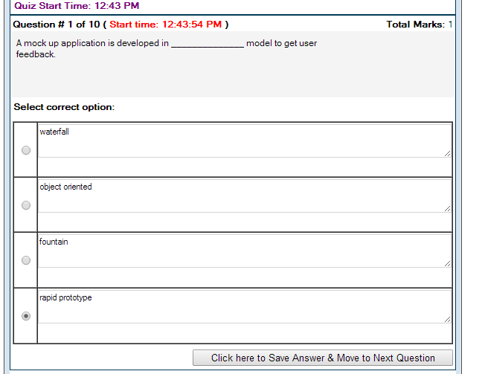
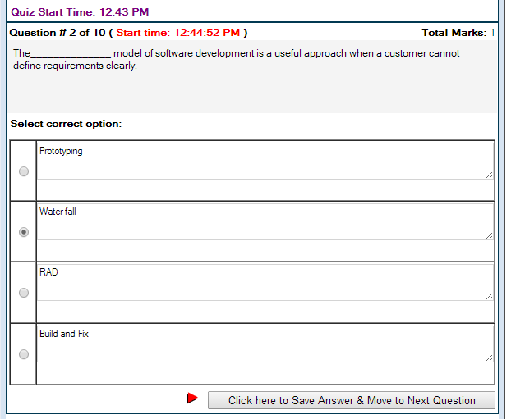
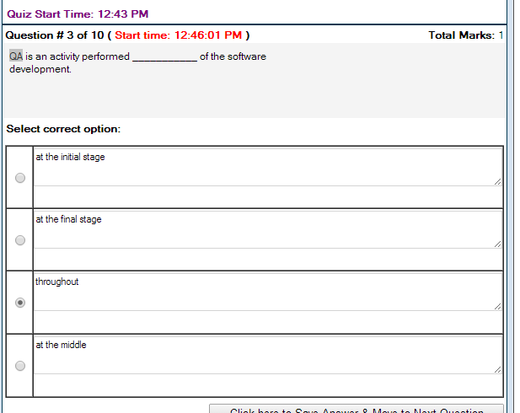
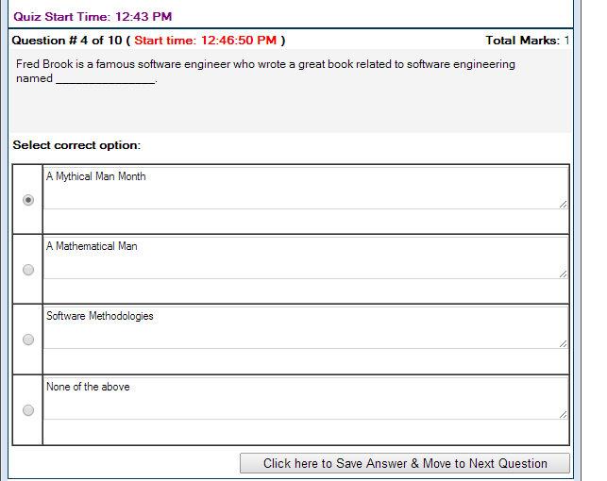
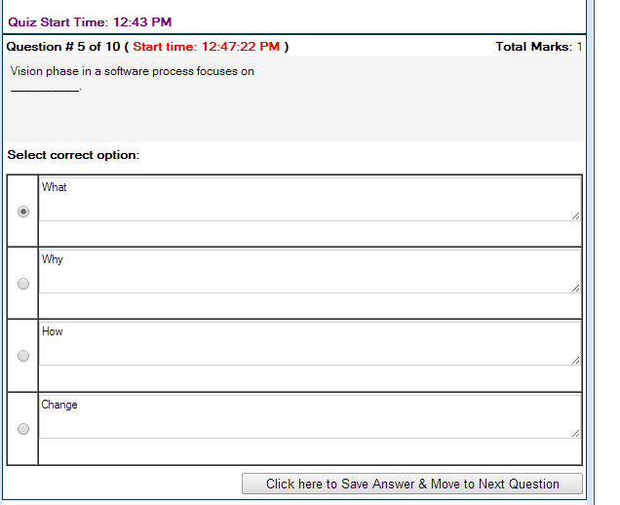
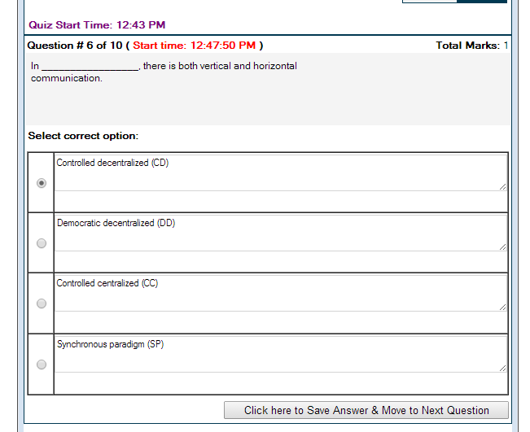
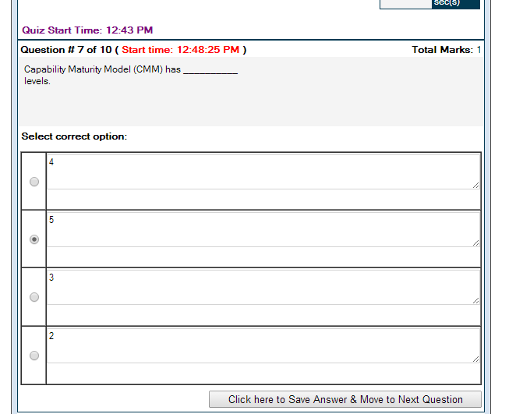
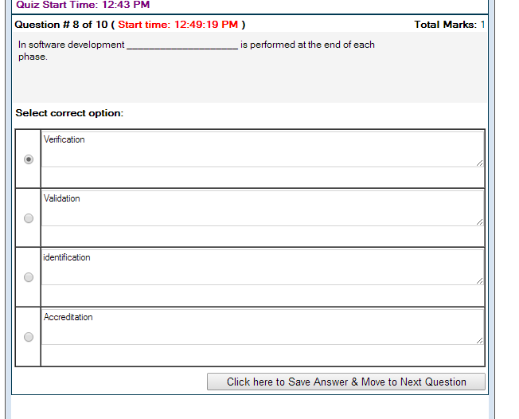

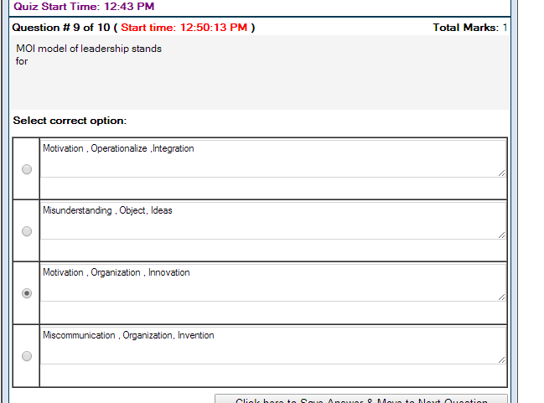
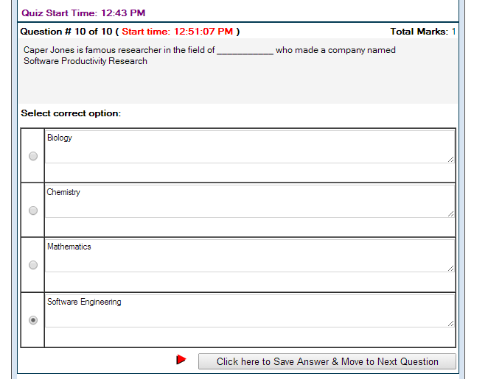
- Page=17
- Page=17
- Page=25
- page=7

- PAGE=14
- PAGE= 32
- PAGE=12
- PAGE=26
- 30
- 27

Quiz Start Time: 06:49 PM | Time Left 22 sec(s)

Question # 1 of 10 ( Start time: 06:49:38 PM ) | Total Marks: 1
_________ model is opposite to waterfall model.
Select correct option:
True

Top of Form
Quiz Start Time: 06:49 PM | Time Left 86 sec(s)

Question # 2 of 10 ( Start time: 06:51:07 PM ) | Total Marks: 1
Rapid application development is another form of _________________.
Select correct option:
True

Top of Form
Quiz Start Time: 06:49 PM | Time Left 60 sec(s)

Question # 3 of 10 ( Start time: 06:51:45 PM ) | Total Marks: 1
MOI model of leadership stands for
Select correct option:
True

Top of Form
Quiz Start Time: 06:49 PM | Time Left 68 sec(s)

Question # 4 of 10 ( Start time: 06:52:33 PM ) | Total Marks: 1
Software Engineering is the set of __________and ___________to develop software.
Select correct option:
True

Top of Form
Quiz Start Time: 06:49 PM | Time Left 59 sec(s)

Question # 5 of 10 ( Start time: 06:53:38 PM ) | Total Marks: 1
In software development ____________________ is performed at the end of each phase.
Select correct option:
True

Bottom of Form

Top of Form
Quiz Start Time: 06:49 PM | Time Left 83 sec(s)

Question # 6 of 10 ( Start time: 06:54:51 PM ) | Total Marks: 1
Fred Brook is a famous software engineer who wrote a great book related to software engineering named _______________.
Select correct option:
True

Top of Form
Quiz Start Time: 06:49 PM | Time Left 88 sec(s)

Question # 7 of 10 ( Start time: 06:55:39 PM ) | Total Marks: 1
At Level-1 organizations follow _________processes.
Select correct option:
True

Top of Form
Quiz Start Time: 06:49 PM | Time Left 80 sec(s)

Question # 8 of 10 ( Start time: 06:57:21 PM ) | Total Marks: 1
________________ model is adopted by Microsoft
Select correct option:
True

Top of Form
Quiz Start Time: 06:49 PM | Time Left 88 sec(s)

Question # 9 of 10 ( Start time: 06:57:53 PM ) | Total Marks: 1
Build and fix model is good for _______ programs that do not require _____________.
Select correct option:
True

The______________ model of software development is a useful approach when a customer cannot define requirements clearly. The______________ model of software development is a useful approach when a customer cannot define requirements clearly.

Prototype
The______________ model of software development is a useful approach when a customer cannot define requirements clearly. Bottom of Form
Bottom of Form
Bottom of Form
Bottom of Form
Bottom of Form
Bottom of Form
Bottom of Form

CS605 Solved MCQS with Reference for Midterm Mega Collection in One File
Every task should be assigned to a specific team -------------.

Member p#89
Manager
Organizer
None of the given

http://vuzs.net
Which one is not the Software project planning activity carried out by the project manager for estimation?

Software scope estimation

Resources requirements

Time requirements

Product Quality p# 75

http://vuzs.net
While performing risk analysis, the impact of risk can not be measured quantitatively
True
False p# 81
http://vuzs.net
Degree of uncertainty that the product will meet its requirements and be fit for its intended use is the

Cost risks

Schedule risks

Performance risks p# 83

None of the given choices

http://vuzs.net
Proactive risk management philosophy is also some times termed as Indiana Jones School of risk management

True
False p#80

http://vuzs.ne

http://vuzs.net
Defect Removal Efficiency (DRE) can be measured by where E is Errors found delivery and D is error found after delivery (typically within the first year of operation)

DRE= E/ (E+D) p#65
DRE= E - (E+D)
DRE= E * (E+D)
None of the given

http://vuzs.net
Integrity means that the software should

Help the users to enjoy usability
None of the given

Withstand the attack from a hacker p#65
Help the hacker to hack the system

http://vuzs.net
In function point analysis technique EO stands for

Export operation

Export output

External output p#44

None of these

http://vuzs.net
Which of these software characteristics are used to determine the scope of a software project?

Context, lines of code, function

Context, function, communication requirements

Information objectives, function, performance

Communications requirements, performance, information objectives p#75

http://vuzs.net

http://vuzs.net
______________ is the first stage of waterfall lifecycle model

Requirement definition p#13
Operation
Unit testing
Implementation

http://vuzs.net
___________ is not the part of software development loop.

Status Quo

Problem definition
Technical development

Task set p#8

http://vuzs.net
__________ is not the management part of software development activities.

Coding p#7

Configuration Management

Quality Assurance

Project planning

_____________________ Phase in a software process focuses on change.

Vision
Maintenance p#12
Definition
Development

________________ Model is adopted by Microsoft

RAD
Build and Fix
Spiral
Synchronize and Stabilized p#17

______________ Model has a major drawback in that the delivered product may not fulfill the customer's requirements.
Select correct option:

Water fall
Build and Fix
Prototyping

Integrated waterfall and prototyping p#15

The important feature of extreme programming is the concept of __________________.
Select correct option:

Feedback
Risk assessment
Pair Programming p#20
Requirement elicitation

__________________paradigm, structures a team loosely and depends on individual initiative of the team members
Select correct option:

Closed
Open
Random p#29
Synchronous

_______________ Model is developed keeping in mind the element of risk in the development of software
Select correct option:
Spiral p#18
RAD
Incremental
Synchronize and Stabilize
Effective software project management focuses on the four P’s: These are
Select correct option:

People, Product, Process, Problem
People, Passion, Process, Project
People, Product, Process, Project p#27
People, Passion, Planning, Project

In ________________ model the product is developed without any proper design and specifications.
Select correct option:

Water fall
Build and Fix p#13
Prototyping
None of the given
The _______________ dimension in rational unified process model represents the dynamic aspect of the process.

Angular
Horizontal p#21
Vertical
Regular

Unrealistic deadline is NOT one of the reasons of project failure.
True
False p#88

Rapid application development is another form of _________________.
:

Prototyping model
Incremental Model p#17
Linear Sequential model
None of the above

___________________ is an Object Oriented model.
:

Spiral
Water fall
Incremental
Fountain p#20

Spiral model has _____________ dimensions.
2 p#18
3
4
None of the above

_____________dimension of Spiral model represents the cumulative cost to date

Angular
Radial p#18

Vision phase in a software process focuses on __________.

What
How
Why p#12
Change
____________________ Teams generate more and better solutions than individuals and are most useful for complex problems

Decentralized p#29
Centralized

In _________________, there is both vertical and horizontal communication.

Democratic decentralized (DD)
Controlled Decentralized (CD) p#29
Controlled centralized (CC)
Synchronous paradigm (SP)

The _____________ model is used to overcome issues related to understanding and capturing of user requirements.
Select correct option:

Water fall
Rapid Prototyping p#15
Build and Fix
None of the above

Pair programming is associated with:
RAD
Incremental development
Extreme Programming p#20
Prototyping
Synchronize and stabilize

Which one of the following is NOT a useful indicator of software quality?
Correctness
Code size p#63
Maintainability
Integrity
Usability
Which one of the following does not belong to a strategy for dealing with risk?
Risk avoidance
Security risk assessment p#86
Risk monitoring
Risk management and Contingency planning

Three categories of risks are
Business risks, personnel risks, budget risks
Project risks, technical risks, business risks p#82
Planning risks, technical risks, personnel risks
Management risks, technical risks, design risks
The software reengineering process model includes restructuring activities for which of the following work items?
Code
Documentation
Data
All of the given options p#65

One graphical technique for determining whether a process exhibits out-of-control change behavior is a.
Control chart p#70
Fishbone diagram
Pareto diagram
Process diagram

The first step in project planning is to
Determine the budget.
Select a team organizational model.
Determine the project constraints.
Establish the objectives and scope. p#75

A law affirming that to continue after a certain level of performance has been reached
Will result decline in effectiveness. This law is know as
Law of Diminishing returns p#4
Law of effectiveness
Law of Saturation
Law of Marketing returns

Build and Fix model is a ___________ type of software development activity.
. Mathematical
. Perfect
. Haphazard (Reference book) p#32
. Planned

In _________________ a team is structured along a traditional hierarchy of authority
. Closed paradigm p#29
. Synchronous paradigm
. Random paradigm
Open paradigm

MTTC is the abbreviation of
. Measured time to change
. Mean time to collaborate
. Mean time to change p#64
. Measure time to cope

FAST is the abbreviation of
Facilitated Application Specification Technology
Facilitated Application Specification Technique p#75
Facilitated Application Specialization Technique
None of the above option

Defect per unit function point is a
Measure
Metric p#61
Measurement
None of the above

The rapid application development model is

A useful approach when a customer cannot define requirements clearly
Speed adaptation of the linear sequential model p#17
Both are true
None of them is true
Several entities are always created -------------- and deleted together then this is a strong indication that they should be grouped into ---------- logical file/files.
Select correct option:
Together, Single p#43
Together, Multiple
Together, Double
All of the given

Chart that is used to develop the individual control chart is called statistical control techniques.
Select correct option:
Yes p#69
No

A --------------entity is the one which have any ----------- in the problem domain without some other entity.
Select correct option:
Strong, Role*
All of the given
Weak, Function
None of the Given p# 47

------------------give you a better insight into the state of the process or product.
Select correct option:
Metrics p#62
Efficiency
Reliability
Usability
We need to employ some statistical techniques and plot the result ---------------. This is known as Statistical control techniques.
Select correct option:
Graphically p#69
Automatically
Manually
Personally

The extent to which a program satisfies its specifications and fulfills the customer’s mission objectives is …………………

Integrity
Reliability
Correctness p#63
None of given
Metrics to assess the quality of the analysis models and the corresponding software specification were proposed............
Ricado in 1993
Davis in 1990
Davis in 1993 p#60
The most important objective of any engineering activity is to produce high quality product with limited resources and-----------------------
Select correct option:
Time p#62
Persons
Cost
Metrics

The amount of computing resources required by a program to perform its function is …………………..
Select correct option:
Efficiency p#63
Integrity
Reliability
None of given

Of the ....................is a pre-requisite of all sorts of estimates, including, resources, time, and budget.
Select correct option:
Software scope p#75
Software Risk
Software Quality
Software Management

Extent to which access to software or data by unauthorized persons can be controlled and called
……….…
Select correct option:
None of given
Efficiency
Reliability
Integrity p#63
ILF is a --------------- identifiable group of logically control in formations ------------- the boundary the application.
Select correct option:
User, within p#37
User, without
All of the given
User, along

The level 1 of CMM is known as
Managed
Defined
Initial p#10
Repeatable
After building the Decision Tree, following formula is used to find the expected cost for
Choose the correct formula:
Expected Cost= (path probability) i * (estimated path cost) p#78
Expected Cost= (path probability) i / (estimated path cost)
Expected Cost= (path probability) i + (estimated path cost)
Expected Cost= (path probability) i - (estimated path cost)
__________________is data that influences an elementary process of the application
Elementary Process
External Query
External Output
Control Information p#37

Empirical models are statistical models and are based upon historic data
True p#76
False

An entity which defines many-to-many relationship between two or more entities is called
Associative Entity Type p#42
Attributive Entity Type
Entity Subtype
None of these

In context of moving range and individual control charts, UNPL stands for:
Universal Natural Process Line
Universal Natural Process Limit
Upper Natural Process Limit p#77
Upper Natural Process Line
The extent to which a program can be expected to perform its intended function with required precision is called ______
Usability
Reliability page 67
Portability
Maintainability
When more than one user interpret the same requirement in different ways then we can say that the requirements are
none of the given
Incomplete
Ambiguous p#63
Incorrect
The Correct statement is
None of the given
The greater the dependency between the components the lesser is coupling
The lesser the dependency between the components the greater is coupling
The greater the dependency between the components the greater is coupling p#69
Function/Test matrix is a type of
Interim Test report
Final test report
Project status report p#126
Management report
In measuring Software Process Quality by using control charts, if the gap between the defects reported and defects fixed is increasing, then it means
The product is in unstable condition p#78
the product is ready for shipment
the product is in stable condition.
None of the above

Quizess:-
Vision phase in a software process focuses on __________.
Select correct option:
What
Why
How
Change
______________ model has a major drawback in that the delivered product may not fulfill the customer's requirements.
Select correct option:
Water fall
Build and Fix
Prototyping
Integrated water fall and prototyping
Quiz Start Time: 02:58 PM Time Left 84
sec(s)
Question # 3 of 10 ( Start time: 02:59:47 PM ) Total Marks: 1
MOI model of leadership stands for
Select correct option:
Motivation , Operationalize ,Integration
Misunderstanding , Object, Ideas
Motivation , Organization , Innovation
Miscommunication , Organization, Invention
The _____________ model is used to overcome issues related to understanding and capturing of user requirements.
Select correct option:
Rapid Prototyping
Water fall
Build and Fix
None of the above
: Water fall model is a document driven model.
Select correct option:
True
False
The Waterfall Model is a documentation-driven model
: Spiral model has _____________ dimensions.
Select correct option:
2
3
4
None of the above
The______________ model of software development is a useful approach when a customer cannot define requirements clearly.
Select correct option:
Prototyping
Water fall
RAD
Build and Fix
Question # 8 of 10 ( Start time: 03:03:57 PM ) Total Marks: 1
_____________________ phase in a software process focuses on change.
Select correct option:
Vision
Maintenance
Definition
Development
____________activity is performed throughout software production
Select correct option:
Maintenance
Development
Analysis
Quality Assurance
__________________paradigm,structures a team loosely and depends on individual initiative of the team members
Select correct option:
Closed
Random
Open
Synchronous
: In ________________ model the product is developed without any proper design and specifications.
Select correct option:
Water fall
Build and Fix
Prototyping
None of the abov
model is a haphazard type of software development activity.
Select correct option:
Water fall
Incremental
Prototyping
Build and Fix
Rapid application development is another form of _________________.
Select correct option:
Incremental model
Prototyping model
Linear Sequential model
None of the above
software project management focuses on the four P’s: These are
Select correct option:
People , Product , Process , Problem
People , Product , Process , Project
People , Passion , Process , Project
People , Passion , Planning , Project
: ___________ model of software development is a good approach when core product is required quickly.
Select correct option:
Incremental
Linear Sequential
Prototyping
None of the above
: The _______________ dimension in rational unified process model represents the dynamic aspect of the process.
Select correct option:
Horizontal
Angular
Vertical
Regular
model is developed keeping in mind the element of risk in the development of software
Select correct option:
Spiral
RAD
Incremental
Synchronize and Stabilize
_______________ model is adopted by Microsoft
Select correct option:
RAD
Build and Fix
Spiral
Synchronize and Stabilize
_______________ model is adopted by Microsoft
Select correct option:
RAD
Build and Fix
Spiral
Synchronize and Stabilize

In ________________ model the product is developed without any proper design and specifications.
Select correct option:
Water fall
Build and Fix
Prototyping
None of the above
?
____________________ teams generate more and better solutions than individuals and are most useful for complex problems
Select correct option:
Decentralized
Centralized
: ________________ model is adopted by Microsoft
Select correct option:
RAD
Build and Fix
Spiral
Synchronize and Stabilize
: In _________________, there is both vertical and horizontal communication.
Select correct option:
Controlled decentralized (CD)
Democratic decentralized (DD)
Controlled centralized (CC)
Synchronous paradigm (SP)
Bookmark
In _________________, there is both vertical and horizontal communication.
Select correct option:
Controlled decentralized (CD)
Democratic decentralized (DD)
Controlled centralized (CC)
Synchronous paradigm (SP)
: The _____________ model is used to overcome issues related to understanding and capturing of user requirements.
Select correct option:
Rapid Prototyping
Water fall
Build and Fix
None of the above
Bookmark
The _______________ dimension in rational unified process model represents the dynamic aspect of the process.
Select correct option:
Horizontal
Angular
Vertical
Regular
_____________dimension of Spiral model represents the cumulative cost to date
Select correct option:
Radial
Angular
: Rapid application development is another form of _________________.
Select correct option:
Incremental model
Prototyping model
Linear Sequential model
None of the above

Software Engineering CS605 Solved MCQs for Final Term Mega Collection with Reference

MCQs of Lecture 1
(Introduction to SE)

1 SE is the set or the combination of processes and tools to develop software

True Lec# 1 P#2

2 All the things that are related to ……………. Are also related to SE

Software Lec#1 P#2

3 Now days ……………. Language is widely being used.

Object Oriented Programming Lec#1 P#2

4 Characteristics of well engineered software are

Reliable, User Friendly, Quality Assurance, Cost Effective Lec#1 P#2

5 SE is actually a …………………

Balancing act Lec 1 P#3

6 There is always a……………….. among all the requirements of a software

Trade-off Lec#1 P#3

7 ………….. is the process of balancing among different characteristics of a software

Software Development Lec#1 P#4

8 A law affirming that to continue after a certain level of performance has been reached will result decline in effectiveness. This law is know as……………………….

Law of Diminishing returns Lec#1 p#4

9 Coper Jones divided the software activities into………………….

25 different categories Lec#1 P#5

10 Coding is not more than……………. the whole effort of software development.

13-14% Lec#1 P#5

11 according to Fred Brook, Software is like a…………….

Giant Lec#1 P#6

12 SE is nothing but a …………………….. To software development

Disciplined and Systematic approach Lec#1 P#6

13 ………………Activities are directly related to development of the software

Construction Lec#1 P#6

14 Requirement gathering, design, coding, testing are activities related to ……………………..

Construction of software Lec#1 P#6

15 ……………… are kind of umbrella activities used to smoothly and successfully perform construction activities.

Management activities Lec#1 P#6

16 Project Planning Management, Configuration management, SQA, Installation and training activities are related to …………

Management Lec#1 P#6

17 ……………… is surrounded by management activities

Construction Lec#1 P#7

18 Software development organizations must focus
On……………. While performing SE activities

Quality Lec#1 P#7

19 …………… are the set of Key Process area and define the tasks to perform and the order in which they are performed.

Processes Lec#1 P#7

20 ……………….. Provide the technical “How-to’s “to carry out tasks

Methods Lec#1 P#7

21 There could be…………………. Technique to perform a task

More than one technique Lec#1 P#7

22 Every task has some……………… and every deliverable should be delivered at particular …………………

Deliverable, Milestone Lec#1 P#7

23 ………………. Techniques could be used in different situations to perform a task.

Different Lec#1 P#7

24 …………………. Provides automated or semi automated support for software processes, methods and quality control.

Tools Lec#1 P#7

25 Software development activities could be performed in a cycle and that cycle is called……………….

Software Development Loop Lec#1 P#8

26 Problem Definition, Technical Development, Solution Integration and Status Quo are stages of……………..

Software Development Loop Lec#1 P#8

27 In………………….. Stage of software development loop we try to determine what is the problem against which we are going to develop software

Problem definition Lec#1 P#8

28 In………………….. Stage of software development loop we try to find the solution of the problem on technical grounds and base our actual implantations on it.

Technical Development Lec#1 P#8

29 ………………….. Is the stage of software development loop where a new system is actually developed to solve the problem defined in the first stage of software development loop?

Technical Development Lec#1 P#8

30 The situation in software development loop where we actually deploy the new system at user site is called………………

Status Quo Lec#1 P#8

31 The stage of software development loop in which interaction of newly developed system takes place with already developed systems is known as…………….

Solution integration Lec#1 P#8

32 In Software development loop once we get new requirements, then we need to change the…………….

Status Quo Lec#1 P#8

MCQs of Lecture 2

(Software Process)

33 ………………… is the road map that helps to produce timely and high quality result (software). It provides stability and control.

Software Process Lec#2 P#10

34 Each process defines certain deliverables known as…………….

Work products Lec#2 P#10

35 Work Products include…………………. Produced as a consequence of SE activities

Programs, documents and data Lec#2 P#10

36 CMM stands for……………….

Capability Maturity Model Lec#2 P#10

37 CMM is developed by…………………

Software Engineering Institute Lec#2 P#10

38 CMM is developed by SEI to judge the ………… of an organization

Process maturity level Lec#2 P#10

39 CMM is divided into……………………… different levels

Five Lec#2 P#10

40 The CMM level in which the software process is characterized as ad-hoc is ……….

Level 1 Initial Level Lec#2 P#10

41 By default every organization would be at…………… of CMM

Level 1 Initial Level Lec#2 P#10

42 Levels of CMM are characterized as …………….

Initial, Repeatable, Defined, Managed, Optimizing Lec#2 P#10

43 Success depends upon individual effort and few processes are defined in ………………. Level of CMM

Initial or 1 Level Lec#2 P#10

44 Level of CMM in which basic project management processes are established to track cost, schedule and functionality is ………….

Repeatable or Level 2 Lec#2 P#10

45 Level of CMM in which process for both management engineering activities is documented, standardized and integrated into an organized software process is ………….

Defined or Level 3 Lec#2 P#10

46 In………………. level of CMM detailed measures for software process and product quality are controlled.

Level 4 also known as Managed Level Lec#2 P#10

47 Qualitative feedbacks are associated with……………. Level of CMM

Level 5 Optimizing Level Lec#2 P#10

48 SE has associated ………………. With each maturity level

Key Process areas KPAs Lec#2 P#10

49 ………………… are the overall objectives that the KPA must achieve.

Goals Le#2 P#11

50 …………… are the requirements imposed on the organization that must be met to achieve the goals or provide proof of intent to comply with the goals?

Commitments Lec#2 P#11

51 …………………. Should be technically and organizationally in place to enable the organization to meet the commitments

Abilities Lec#2 P#11

52……………….. Are the specific tasks required to achieve the KPA function?

Activities Lec#2 P#11

53………… are used to verify implementation or it is the manner in which proper practice for the KPA can be verified.

Methods Lec#2 P#11

54 For ………… level of CMM, No KPAs are defined.

Level 1 or initial level Lec#2 P#11

MCQs of Lecture 3

(Software Lifecycle Model)

55 software systems passes through……………… phases

Four Phases Lec#3 P#12

56 Phases of a software system are …………………

Vision, definition, development and maintenance Lec#3 P#12

57 Vision phase in software process focuses on …………………

Why Lec#3 P#12

58 Definition phase in software process focuses on …………………

What Lec#3 P#12

59 Development phase in software process focuses on …………………

How Lec#3 P#12

60 Maintenance phase in software process focuses on …………………

Change Lec#3 P#12

61 ………………… is series of steps through which a product progresses.

Lifecycle Model Lec#3 P#12

62 ………………… depict the way you organize your activities.

Lifecycle Model Lec#3 P#12

63 In ………………… model product is constructed without specification or any attempt at design

Build & Fix model Lec#3 P#13

64 Build and fix model is suitable to develop …………… projects

Small Lec#3 P#13

65 The cost of build and fix is actually far……………….. than the cost of properly specified and carefully designed product.

Greater Lec#3 P#13

66 In case of build and fix model maintenance of the product can be………………… in the absence of any documentation

Extremely Lec#3 P#13

67 Using………………….. Model developer can build a product that is reworked as many times as needed to satisfy the client.

Build and Fix Model Lec#3 P#13

68 ………………….. Is a linear sequential model

Waterfall Model Lec#3 P#13

69 ………………….. Is documentation driven model

Waterfall Model Lec#3 P#15

70 ………………….. Generate complete and comprehensive documentation

Waterfall Model Lec#3 P#15

71 waterfall models make the maintenance much…………

Easy Lec#3 P#15

72 …………………… model has major time and cost related consequences

Waterfall Model Lec#3 P#15

73 ……………………. is the first stage of waterfall lifecycle model

Requirement definition Lec#3 P#13

74 Real projects…………….. Follow the sequential flow that the model proposes.

Rarely Lec#3 P#14

75 The purpose of ………………… model is to capture client’s need (user requirements)

Rapid Prototyping Model Lec#3 P#15

76…………….. Has major drawback that the delivered product may not fulfill the client’s needs

Waterfall Model Lec#3 P#15

77 to fulfill client’s needs, one solution is the combination of…………..

Rapid Prototyping and Waterfall Model Lec#3 P#15

MCQs of Lecture 4

(Incremental Model)

78 ……………….. Model is used when requirements are fully understood.

RAD Rapid Application Development Lec#4 P#17

79…………….. Results in delayed feed back from the client.

Waterfall Model Lec#4 P#16

80 In case of waterfall model, entire product is developed and delivered to the client in ……………. Package

One Package Lec#4 P# 16

81 in ………………… model product is partitioned into smaller pieces which are built and delivered to the client.

Incremental Model Lec#4 P#16

82 Incremental models results in………….. Feedback from the client

Quick Lec#4 P#16

83 ………………….less traumatic as compared to waterfall model.

Incremental Model Lec#4 P# 16

84 There are ………………. basic fundamental approaches to the incremental development.

Two Lec#4 P#16

85 RAD is the form of……………… model

Incremental Model Lec#4 P#17

86……………… model is adopted by Microsoft

Synchronize and Stabilize Model Lec#4 P#17

87 Spiral model was developed by……………

Barry Boehm Lec#4 P#18

88 There is always an element of …………. In software development activity

Risk Lec#4 P#18

89 Spiral model is……………..

Waterfall model and Risk analysis Lec#4 P#18

90 Spiral Model has ………………. Dimensions

Two Lec#4 P#18

91 Spiral Model has two dimensions named as ……………

Radial and Angular dimensions Lec#4 P#18

92 Radial dimension of spiral model represents……………..

Cumulative cost to date Lec#4 P#18

93 Angular dimension of spiral model represents……………..

Progress through the spiral Lec#4 P#18

94……………… is very sensitive to risk

Spiral Model Lec#4 P#19

95 Spiral model is used to develop………………

Large scaled software Lec#4 P#19

MCQs of Lecture 5

(Object Oriented Lifecycle Models)

96 Very important feature of Extreme Programming is ……………..

Pair Programming Lec#5 P#20

97 One very important restriction imposed in the extreme programming object oriented model is that no team is allowed to work overtime for………………………

Two successive Weeks Lec#5 P#20

98 ……………….. Is Object Oriented Lifecycle model

Fountain model Lec#5 P#20

99 Arrows in fountain model represent………………. Within the phase

Iteration Lec#5 P#21

100 Maintenance cycle of fountain model is………………

Smaller Lec#5 P#21

101 RUP stands for…………………..
Rational Unified Process Lec#5 P#21

102 RUP is closely related to ……………………..Model

UML and Krutchen’s Model Lec#5 P#21

103 In RUP model…………….. Represents dynamic aspect of process

Horizontal dimension Lec#5 P#21

104 In RUP model…………….. Represents static aspect of process

Vertical dimension Lec#5 P#21

105 In RUP model during development all the activities are performed in……………..

Parallel Lec#5 P#21

106 No single model may fulfill the needs in a given situation

True Lec#5 P#22

107 There is no separate QA (quality assurance) or documentation phase

True Lec#5 P#22

108………………… is an activity performed throughout software production?

QA (Quality Assurance) Lec#5 P#22

109 QA involves two things named as……………………

Verification and validation Lec#5 P#22

110………………… is performed at the end of each phase

Verification Lec#5 P#22

111……………. Is performed before delivering the product to the client

Validation Lec#5 P#22

MCQs of Lecture 6

(Software Project Management Concepts)

112 Good ………………….. Is associated with 100% successful project

Project Management Lec#6 P#24

113 ………………….. Involves planning, organization, monitoring and control of people and the process

Software project Management. Lec#6 P#24

114 As the project size increases, the complexity of the problem also………………….

Increases Lec#6 P#24

115……………………… specify the conditions and the restrictions imposed on the system.

Non functional Requirements or System constraints Lec#6 P#24

116…………………. Has to ensure that the required no of resources is available to the project

Project Manager Lec#6 P#25

117 Project Management is …………………… intensive activity

People intensive Lec#6 P#27

118……………….. Is the outcome of the project?
Product Lec#6 P#26

119……………… has highest priority on project manager’s agenda

People Lec#6 #26

120 There are …………………P’s related to project management

Four Lec#6 P#26

121 There are four P’s related to project management named as………….

People, Product, Process and Project Lec#6 P#26

122 MOI stands for…………………..?

Motivation, Organization and Innovation Lec#6 P#27

123 MOI Model is developed by……………………

Weinberg Lec#6 P#27

124 ……………. Is the ability to encourage people to produce their best?

Motivation Lec#6 P#27

125 ……………. Is the ability to mold the existing processes to be translated into a final product?

Organization Lec#6 P#27

126 ……………. Or the idea is the ability to encourage people to create and feel creative

Innovation Lec#6 P#27

127 Successful project managers always apply ………………… management style
Problem Solving Lec#6 P#27

128 ……………….. Involves developing an understanding of problem and motivating the team to generate ideas to solve the problems

Problem solving management style Lec#6 P#27

129 according to Demarko, a good leader has …………… characteristics

Four characteristics (Heart, Nose, Gut and Soul) Lec#6 P#28

MCQs of Lecture 7

(The Software Team)

130 ………………paradigm, structures a team loosely and depends on individual initiative of the team members

Random Lec#7 P#29

131 ………………..Teams generate more and better solutions than individuals and are most useful for complex problems

Decentralized Lec#7 P#29

132 In ……………….there is both vertical and horizontal communication.

Controlled Decentralized (CD) Lec#7 P#29

133 ………………..complete tasks faster and are most useful for handling simple problems

Centralized Structure Lec#7 P#29

134 In ………… a team is structured along a traditional hierarchy of authority

. Closed paradigm Lec#7 P#29

135 ………………….. Relies on natural compartmentalization of problem

Synchronous paradigm Lec#7 P#29

136 ……………… involves control activities of close and random paradigm

Open Paradigm Lec#7 P#29

137 In …………………. Organization there is no permanent leader

Democratic Decentralized Lec#7 P#29

138 In Democratic Decentralized organization communication is …………

Horizontal Lec#7 P#29

139 In …………………. There is a defined leader who coordinates specific tasks
Controlled Decentralized Lec#7 P#29

140 In Controlled Centralized communication is……………..
Vertical Lec#7 P#29

141 In …………….. Top level problem solving and internal team coordination are managed by the team leader.

Controlled Centralized Lec#7 P#29

142 ……………….. Results in confusion and uncertainty

Lack of coordination Lec#7 P#30

143 Performance is inversely proportional to the amount of ………………

Communication Lec#7 P#30

144 Too much communication and coordination is …………. Healthy for a project

Not Healthy Lec#7 P#30

145 Kraul and Steeter categorized the project coordination techniques as ……………………

Formal impersonal, Formal interpersonal and informal interpersonal approaches Lec #7 P#30

146 SE documents, technical memos, schedules, error tracking reports are examples of …………………. Coordination

Formal impersonal Lec#7 P#30

147 QA activities, Design and Code reviews and status meetings are examples of………………… Coordination

Formal Interpersonal Lec#3 P#30

148 Group meetings and collocating different groups together are examples of………………… Coordination

Informal Interpersonal Lec#3 P#30

149 …………….. Communication includes email and bulletin boards

Electronic Lec#7 P#30

150 ………………….. Includes informal discussions with group members

Interpersonal networking Lec#7 P#30

151 Characteristics used to determine the scope of the software are…………………

Context, information objectives, function and performance requirements Lec#7 P#31

152 To decide which model is to pick the project manager has to look at ………………….. To be built and ……………………

Characteristics of the product & project environment Lec#7 P#31

153 When requirements are uncertain………………… model is suitable
Rapid Prototyping model Lec#7 P#31

154 When degree of uncertainty is minimized and the project is relatively small that is similar to past efforts than………………….. Model can be used

Waterfall Model or linear sequential model Lec#7 P#31

155 For projects with large functionality, quick turn around time ……………. Model is suitable

Incremental Model Lec#7 P#31

156 When requirements are known and there is tight timeliness and heavy compartmentalization then……………. Model is suitable

RAD Rapid Application Development Model Lec#7 P#31
Also see Lec#4 P#17

MCQs of Lecture 8

(The Project)

157……………… ensures timely delivery and remedial action

Tracking Lec#8 P#32

To learn from mistakes and to improve the process continuously……………… Must be conducted

Project postmortem Lec#8 P#32

158……………… suggested a systematic approach to project management known as WWWWWHH Principle

Barry Boehm Lec#8 P#32

159 Barry Boehm suggested a systematic approach to project management known as………………..

WWWWWHH Principle Lec#8 P#32

160 WWWWWHH principles comprises of ………………. Questions

Seven Lec#8 P#32
161 WWWWWHH principles include 7 questions named as……………….

Why, What, When, Who, Where, How, How much Lec#8 P#32

162 WWWWWHH principles are applicable regardless of ………………. Of the project and provides excellent…………….. Outline

Regardless of size and complexity of the project and provides excellent planning outline Lec#8 P#32

MCQs of Lecture 9

(Software Size Estimation)

163 …………………. Plays important role in determining the cost of the project

Time and Resources estimation Lec#9 P#33

164 The size of the project needs to be estimated to figure out the ………………. And ………………

Time and number of resources Lec#9 P#33

165 LOC stands for …………………..

Line of Code Lec#9 P#33

166 If mixture of languages and tools is used then comparison even becomes more………………..

Difficult Lec#9 P#33

167 LOC is technology (programming style) ………………
Dependent Lec#9 P#33
168………… measures the size of the functionality provided by the software

FP Functional Point Lec#9 P#33

169……………….. Is measured as a function of the data and the operation performed on the data

Functionality Lec#9 P#33

170………………….. Can be counted only after the code has been developed

LOC Line of Code Lec#9 P#34

171……………… can be counted even at requirement phase and use for planning and estimation

FP Functional Point Lec#9 P#34

172……………. Can not be used for planning and estimation

LOC Line of Code Lec#9 P#34

173…………. Measure application from developer’s perspective

LOC Line of Code Lec#9 P#34

174………………. Measures the size of functionality from user’s perspective

FP Functional Point Lec#9 P#34

175……………….. Is the description of business functions and is approved by user and represents user needs

User view Lec#9 P#34

MCQs of Lecture 10

(Function Point Counting Process)

176 Function point count can be divided into………… categories

Three Lec#10 P#36

177 Function point count can be divided into three categories named as……………………

Development count, Enhancement Count and Application Count Lec#10 P#36

178 The application boundary of two counts is……………. And scope independent

Same Lec#10 P#37

179 ……………… includes all functions impacted by the project activities

Development Function point count Lec#10 P#36

180……………… includes all functions being added changed or deleted

Enhancement Function point count Lec#10 P#36

181……………… may include only the functions being used by the user or all the functions delivered

Application Function point count Lec#10 P#36

182……………….. Basically the system’s context diagram and determines the scope of count

Application Boundary Lec#10 P#37

183………………… indicates border b/w the software and user

Application Boundary Lec#10 P#37

184 Data is divided into …………….. Categories on the basis of count data functions

Two Lec#10 P#37

185 ILFs stands for ………………………..

Internal Logical Files Lec#10 P#37

186 EIFs stands for ………………………..

External Interface Files Lec#10 P#37

187…………….. Is a user identifiable group of logically related data maintained within the boundary of the application?

ILF Internal Logical File Lec#10 P#37

188…………….. Is a user identifiable group of logically related data referenced by the application but maintained within the boundary of another application

External Interface Files EIFs Lec#10 P#37

189 EIF counted for an application must be in an……………… in another application

ILF Lec#10 P#37

190…………………. Is the data that influence an elementary process of the application being counted?

Control information Lec#10 P#37

191 Term…………… refers to defined requirements that are understood by both user and software developers

User identifiable Lec#10 P#38

192 Term ……………… is the ability to modify data through an elementary process

Maintained Lec#10 P#38

193 ………………. Is the smallest unit of activity that is meaningful to the user?

Elementary Process Lec#10 P#38

194 DETs stands for………………..

Data element types Lec#10 P#38

195 RETs stands for…………………….

Record Element types Lec#10 P#38

196……………… is unique user recognizable non repeatable field

Data Element Type DET Lec#10 P#39

MCQs of Lecture 11

(Function Point Counting Process)

197……………… is user recognizable subgroup of data elements within an ILF or ELF

Record Element types Lec#11 P#41

198 There are …………….. Types of RET subgroups

Two Lec#11 P#41 Optional and Mandatory subgroups

199…………………. Are the subgroups that the user has the option to choose one or none of the subgroups during an elementary process?

Optional Subgroups Lec#11 P#41

200…………………. Are the subgroups that the user must use at least one during an elementary process?

Mandatory Subgroups Lec#11 P#41

201An elementary process can maintain ……………….ILF

More than one Lec#11 P#42

202 We can count ILF or ELF only………………

Once Lec#11 P#42

203 An application can use an ILF or EIF …………… times in an elementary process

Multiple times Lec#11 P#42

204Entity is…………….. Representation of data

Logical Lec#11 P#42

205………………. Is something (person, place or thing) about which information is kept?

Entity Lec#11 P#42

206Entity that represents relationship b/w two or more entities are………………
Associative entity Lec#11 P#42

207An entity can be weak or strong entity

True Lec#11 P#42

208 Entity that represents subset of information about instance of an entity is called ………………

Subtype entity Lec#11 P#42

209…………… is principle data object

Entity Lec#11 P#42

210The entity that can exist independently without some other entity is…………………..

Strong entity Lec#11 P#42

211The entity that can not exist independently without some other entity is…………………..

Weak Entity Lec#11 P#42

212 The entity type that describes one or more characteristics of another entity is ………………

Attribute entity type Lec#11 P#42

213The entity type that describes many to many relationship b/w two or more entity is ………………

Associative entity type Lec#11 P#42

If several entities are always created together and deleted together then this is a strong indication that they should be grouped into a ……………… logical file

Single Lec#11 P#43

……………… is defined as requirements specially requested by the user to complete elementary process

Processing Logic Lec#11 P#44

Question # 1 of 10 ( Start time: 05:50:00 AM ) | Total Marks: 1
In Rational Unified Process (RUP) horizontal dimension represents the ___________ aspect of the process.
Select correct option:
correct

Saving...
Question # 2 of 10 ( Start time: 05:51:07 AM ) | Total Marks: 1
There are two very different approaches to cost estimation. The older approach is called LOC estimation, since it is ………….. on initially estimating the number of lines of code that will need to be developed for the project.
Select correct option:
Saving...
Question # 3 of 10 ( Start time: 05:52:31 AM ) | Total Marks: 1
Vision phase in a software process focuses on __________.
Select correct option:
correct

Saving..
Question # 4 of 10 ( Start time: 05:54:01 AM ) | Total Marks: 1
If requirements are uncertain, ______________ model will be a suitable option.
Select correct option:
correct

Question # 5 of 10 ( Start time: 05:54:54 AM ) | Total Marks: 1
Caper Jones is famous researcher in the field of ___________ who made a company named Software Productivity Research
Select correct option:
correct

Question # 6 of 10 ( Start time: 05:55:41 AM ) | Total Marks: 1
Continuous process improvement is enabled by __________ feedback from the __________.
Select correct option:
correct

Question # 7 of 10 ( Start time: 05:56:49 AM ) | Total Marks: 1
W5HH Principle consists of seven ___________.
Select correct option:
correct

 | Quiz Start Time: 05:49 AM Time Left 14 sec(s)
Question # 8 of 10 ( Start time: 05:57:34 AM ) | Total Marks: 1
eXtreme programming model is the concept of _____________programming.
Select correct option:
correct

Question # 9 of 10 ( Start time: 05:59:05 AM ) |  | Total Marks: 1
__________is the ability to encourage technical people to produce to their best.
Select correct option:
correct

Quiz Start Time: 05:49 AM | Time Left 70 sec(s)

Question # 10 of 10 ( Start time: 06:00:11 AM ) | Total Marks: 1
Each process defines certain deliverables known as the _____________.
Select correct option:
correct

CS605 today quiz solved
Quiz Start Time: 06:23 PM
Time Left 89
sec(s)
Question # 1 of 10 ( Start time: 06:23:45 PM ) Total Marks: 1
___________ help in finding the matrix to be stable or unstable
Select correct option:
Control chart
Directed Graph
Cyclic chart
Base line graph
Quiz Start Time: 06:23 PM
Time Left 88
sec(s)
Question # 2 of 10 ( Start time: 06:25:10 PM ) Total Marks: 1
Several entities are always created -------------- and deleted together then this is a strong
indication that they should be grouped into ---------- logical file/files.
Select correct option:
Together, Single
All of the given
Together, Double
Together, Multiple
Quiz Start Time: 06:23 PM
Time Left 87
sec(s)
Question # 3 of 10 ( Start time: 06:25:50 PM ) Total Marks: 1
------------------give you a better insight into the state of the process or product.
Select correct option:
Metrics
Efficiency
Reliability
Usability
Quiz Start Time: 06:23 PM
Time Left 89
sec(s)
Question # 4 of 10 ( Start time: 06:26:17 PM ) Total Marks: 1
Determination of the ....................is a pre-requisite of all sorts of estimates, including,
resources, time, and budget.
Select correct option:
software scope
software Risk
software Quality
software Management
Quiz Start Time: 06:23 PM
Time Left 89
sec(s)
Question # 5 of 10 ( Start time: 06:26:33 PM ) Total Marks: 1
We need to employ some statistical techniques and plot the result ---------------. This is
known as statistical control techniques.
Select correct option:
Graphically
Automatically
Manually
Personally
Quiz Start Time: 06:23 PM
Time Left 89
sec(s)
Question # 6 of 10 ( Start time: 06:26:59 PM ) Total Marks: 1
When more than one user interpret the same requirement in different ways then we can
say that the requirements are
Select correct option:
None of the given
Incomplete
Ambiguous not sure
Incorrect
Quiz Start Time: 06:23 PM
Time Left 89
sec(s)
Question # 7 of 10 ( Start time: 06:28:02 PM ) Total Marks: 1
The extent to which a program satisfies its specifications and fulfills the customer’s
mission objectives is …………………
Select correct option:
Integrity
Reliability
Correctness
None of given
Quiz Start Time: 06:23 PM
Time Left 89
sec(s)
Question # 8 of 10 ( Start time: 06:28:25 PM ) Total Marks: 1
Several entities are always created -------------- and deleted together then this is a strong
indication that they should be grouped into ---------- logical file/files.
Select correct option:
Together, Single
Together, Multiple
Together, Double
All of the given
Quiz Start Time: 06:23 PM
Time Left 89
sec(s)
Question # 9 of 10 ( Start time: 06:28:52 PM ) Total Marks: 1
In case some software, it is extremely easy to operate with intuitive interface conforming
to most excellent GUI practices of the industry. It needs very little training -----------------
Select correct option:
Less than one hour
Less than two hour not sure
Less than five hour
Less than ten hour
Quiz Start Time: 06:23 PM
Time Left 86
sec(s)
Question # 10 of 10 ( Start time: 06:30:21 PM ) Total Marks: 1
Metrics to assess the quality of the analysis models and the corresponding software
specification were proposed ............
Select correct option:
in 1993- 1999.
Ricado in 1993
Davis in 1990
Davis in 1993
Quiz Start Time: 06:31 PM
Time Left 88
sec(s)
Question # 1 of 10 ( Start time: 06:31:40 PM ) Total Marks: 1
Determination of the ....................is a pre-requisite of all sorts of estimates, including,
resources, time, and budget.
Select correct option:
software scope
software Risk
software Quality
software Management
Quiz Start Time: 06:31 PM
Time Left 89
sec(s)
Question # 2 of 10 ( Start time: 06:31:56 PM ) Total Marks: 1
This chart is then used to develop the individual control chart is called statistical control
techniques.
Select correct option:
Yes
No
Quiz Start Time: 06:31 PM
Time Left 89
sec(s)
Question # 3 of 10 ( Start time: 06:33:17 PM ) Total Marks: 1
Which statement is correct?
Select correct option:
None of the given not sure
The greater the dependency between the components the lesser is coupling
The lesser the dependency between the components the greater is coupling
The greater the dependency between the components the greater is coupling
Quiz Start Time: 06:31 PM
Time Left 89
sec(s)
Question # 4 of 10 ( Start time: 06:33:44 PM ) Total Marks: 1
Function/Test matrix is a type of
Select correct option:
Interim Test report
Final test report
Project status report not sure
Management report
Quiz Start Time: 06:31 PM
Time Left 89
sec(s)
Question # 5 of 10 ( Start time: 06:34:41 PM ) Total Marks: 1
Several entities are always created -------------- and deleted together then this is a strong
indication that they should be grouped into ---------- logical file/files.
Select correct option:
Together, Single
Together, Multiple
Together, Double
All of the given
Quiz Start Time: 06:31 PM
Time Left 89
sec(s)
Question # 6 of 10 ( Start time: 06:35:00 PM ) Total Marks: 1
___________ help in finding the matrix to be stable or unstable
Select correct option:
Control chart
Directed Graph
Cyclic chart
Base line graph
Quiz Start Time: 06:31 PM
Time Left 89
sec(s)
Question # 7 of 10 ( Start time: 06:35:13 PM ) Total Marks: 1
The most important objective of any engineering activity is to produce high quality
product with limited resources and-----------------------
Select correct option:
Time
Persons
Cost
Metrics
Quiz Start Time: 06:31 PM
Time Left 88
sec(s)
Question # 8 of 10 ( Start time: 06:35:35 PM ) Total Marks: 1
Extent to which access to software or data by unauthorized persons can be controlled and
called ……….…
Select correct option:
None of given
Efficiency
Reliability
Integrity
Quiz Start Time: 06:31 PM
Time Left 89
sec(s)
Question # 9 of 10 ( Start time: 06:36:00 PM ) Total Marks: 1
The amount of computing resources required by a program to perform its function is
…………………..
Select correct option:
Efficiency
Integrity
Reliability
None of given
Quiz Start Time: 06:31 PM
Time Left 89
sec(s)
Question # 10 of 10 ( Start time: 06:36:21 PM ) Total Marks: 1
.........technique was initially developed for manufacturing processes in the 1920’s by
Walter Shewart.
Select correct option:
Upper Control Line
Contorl chart
CMP
Quality
Quiz Start Time: 06:37 PM
Time Left 89
sec(s)
Question # 1 of 10 ( Start time: 06:37:28 PM ) Total Marks: 1
Extent to which access to software or data by unauthorized persons can be controlled and
called ……….…
Select correct option:
None of given
Efficiency
Reliability
Integrity
Quiz Start Time: 06:37 PM
Time Left 90
sec(s)
Question # 2 of 10 ( Start time: 06:37:48 PM ) Total Marks: 1
___________ help in finding the matrix to be stable or unstable
Select correct option:
Control chart
Directed Graph
Cyclic chart
Base line graph
Quiz Start Time: 06:37 PM
Time Left 89
sec(s)
Question # 3 of 10 ( Start time: 06:37:57 PM ) Total Marks: 1
Function/Test matrix is a type of
Select correct option:
Interim Test report
Final test report
Project status report not sure
Management report
Quiz Start Time: 06:37 PM
Time Left 89
sec(s)
Question # 4 of 10 ( Start time: 06:38:05 PM ) Total Marks: 1
The extent to which a program satisfies its specifications and fulfills the customer’s
mission objectives is …………………
Select correct option:
Integrity
Reliability
Correctness
None of given
Quiz Start Time: 06:37 PM
Time Left 89
sec(s)
Question # 5 of 10 ( Start time: 06:38:30 PM ) Total Marks: 1
Several entities are always created -------------- and deleted together then this is a strong
indication that they should be grouped into ---------- logical file/files.
Select correct option:
Together, Single
Together, Multiple
Together, Double
All of the given
Quiz Start Time: 06:37 PM
Time Left 89
sec(s)
Question # 6 of 10 ( Start time: 06:38:48 PM ) Total Marks: 1
In measuring Software Process Quality by using control charts, if the gap between the
defects reported and defects fixed is increasing, then it means
Select correct option:
The product is in unstable condition.
The product is ready for shipment
The product is in stable condition.
None of the above
Quiz Start Time: 06:37 PM
Time Left 89
sec(s)
Question # 7 of 10 ( Start time: 06:40:12 PM ) Total Marks: 1
When more than one user interpret the same requirement in different ways then we can
say that the requirements are
Select correct option:
None of the given
Incomplete
Ambiguous not sure
Incorrect
Quiz Start Time: 06:37 PM
Time Left 88
sec(s)
Question # 8 of 10 ( Start time: 06:40:22 PM ) Total Marks: 1
This chart is then used to develop the individual control chart is called statistical control
techniques.
Select correct option:
Yes
No
Quiz Start Time: 06:37 PM
Time Left 88
sec(s)
Question # 9 of 10 ( Start time: 06:40:36 PM ) Total Marks: 1
------------------give you a better insight into the state of the process or product.
Select correct option:
Metrics
Efficiency
Reliability
Usability
Quiz Start Time: 06:37 PM
Time Left 89
sec(s)
Question # 10 of 10 ( Start time: 06:41:16 PM ) Total Marks: 1
In case some software, it is extremely easy to operate with intuitive interface conforming
to most excellent GUI practices of the industry. It needs very little training -----------------
Select correct option:
Less than one hour
Less than two hour not sure
Less than five hour
Less than ten hour
Quiz Start Time: 03:18 PM Time Left 88
sec(s)
Question # 1 of 10 ( Start time: 03:18:25 PM ) Total Marks: 1
A --------------entity is the one which have any ----------- in the problem domain without
some other entity.
Select correct option:
Strong, Role*
All of the given
Weak, Function
None of the Given P # 47
Quiz Start Time: 03:18 PM Time Left 88
sec(s)
Question # 2 of 10 ( Start time: 03:19:51 PM ) Total Marks: 1
------------------give you a better insight into the state of the process or product.
Select correct option:
Metrics
Efficiency
Reliability
Usability
Quiz Start Time: 03:18 PM Time Left 86
sec(s)
Question # 3 of 10 ( Start time: 03:21:15 PM ) Total Marks: 1
Several entities are always created -------------- and deleted together then this is a strong
indication that they should be grouped into ---------- logical file/files.
Select correct option:
Together, Single
Together, Multiple
Together, Double
All of the given
Quiz Start Time: 03:18 PM Time Left 89
sec(s)
Question # 4 of 10 ( Start time: 03:22:27 PM ) Total Marks: 1
We need to employ some statistical techniques and plot the result ---------------. This is
known as statistical control techniques.
Select correct option:
Graphically
Automatically
Manually
Personally
Quiz Start Time: 03:18 PM Time Left 89
sec(s)
Question # 5 of 10 ( Start time: 03:23:24 PM ) Total Marks: 1
The extent to which a program satisfies its specifications and fulfills the customer’s
mission objectives is …………………
Select correct option:
Integrity
Reliability
Correctness
None of given
Question # 7 of 10 ( Start time: 03:26:12 PM ) Total Marks: 1
The amount of computing resources required by a program to perform its function is
…………………..
Select correct option:
Efficiency
Integrity
Reliability
None of given
Question # 8 of 10 ( Start time: 03:26:46 PM ) Total Marks: 1
Metrics to assess the quality of the analysis models and the corresponding software
specification were proposed ............
Select correct option:
in 1993- 1999.
Ricado in 1993
Davis in 1990
Davis in 1993
Quiz Start Time: 03:18 PM Time Left 85
sec(s)
Question # 9 of 10 ( Start time: 03:27:19 PM ) Total Marks: 1
The most important objective of any engineering activity is to produce high quality
product with limited resources and-----------------------
Select correct option:
Time
Persons
Cost
Metrics
Question # 10 of 10 ( Start time: 03:27:53 PM ) Total Marks: 1
Function/Test matrix is a type of
Select correct option:
Interim Test report
Final test report
Project status report
Management report
Which statement is correct?
Select correct option:
None of the given
The greater the dependency between the components the lesser is coupling
The lesser the dependency between the components the greater is coupling
The greater the dependency between the components the greater is coupling
help in finding the matrix to be stable or unstable
Select correct option:
Control chart
Directed Graph
Cyclic chart
Base line graph
Several entities are always created -------------- and deleted together then this is a strong
indication that they should be grouped into ---------- logical file/files.
Select correct option:
Together, Single
All of the given
Together, Double
Together, Multiple
The amount of computing resources required by a program to perform its function is
…………………..
Select correct option:
Efficiency
Integrity
Reliability
None of given
Question # 6 of 10 ( Start time: 12:35:50 PM ) Total Marks: 1
The extent to which a program satisfies its specification and fulfills the customer’s
mission objectives is said to be achieving the
Select correct option:
Correctness
Reliability
Efficiency
Usability
Question # 8 of 10 ( Start time: 12:36:40 PM ) Total Marks: 1
We need to employ some statistical techniques and plot the result ---------------. This is
known as statistical control techniques.
Select correct option:
Graphically
Automatically
Manually
Personally
of the ....................is a pre-requisite of all sorts of estimates, including, resources, time,
and budget.
Select correct option:
software scope
software Risk
software Quality
software Management
When more than one user interpret the same requirement in different ways then we can
say that the requirements are
Select correct option:
None of the given
Incomplete
Ambiguous
Incorrect
------------------give you a better insight into the state of the process or product.
Select correct option:
Metrics
Efficiency
Reliability
Usability
Extent to which access to software or data by unauthorized persons can be controlled and
called ……….…
Select correct option:
None of given
Efficiency
Reliability
Integrity
ILF is a --------------- identifiable group of logically control in formations ------------- the
boundary the application.
Select correct option:
user, within
user, without
All of the given
user, along
.........technique was initially developed for manufacturing processes in the 1920’s by
Walter Shewart.
Select correct option:
Upper Control Line
Contorl chart
CMP
Quality
Question # 6 of 10 ( Start time: 12:44:22 PM ) Total Marks: 1
A --------------entity is the one which have any ----------- in the problem domain without
some other entity.
Select correct option:
Strong, Role*
All of the given
Weak, Function
None of the Given
The extent to which a program satisfies its specifications and fulfills the customer’s
mission objectives is …………………
Select correct option:
Integrity
Reliability
Correctness
None of given
Which statement is correct?
Select correct option:
None of the given
The greater the dependency between the components the lesser is coupling
The lesser the dependency between the components the greater is coupling
The greater the dependency between the components the greater is coupling
help in finding the matrix to be stable or unstable
Select correct option:
Control chart
Directed Graph
Cyclic chart
Base line graph
Several entities are always created -------------- and deleted together then this is a strong
indication that they should be grouped into ---------- logical file/files.
Select correct option:
Together, Single
All of the given
Together, Double
Together, Multiple
The amount of computing resources required by a program to perform its function is
…………………..
Select correct option:
Efficiency
Integrity
Reliability
None of given
Question # 6 of 10 ( Start time: 12:35:50 PM ) Total Marks: 1
The extent to which a program satisfies its specification and fulfills the customer’s
mission objectives is said to be achieving the
Select correct option:
Correctness
Reliability
Efficiency
Usability
Question # 8 of 10 ( Start time: 12:36:40 PM ) Total Marks: 1
We need to employ some statistical techniques and plot the result ---------------. This is
known as statistical control techniques.
Select correct option:
Graphically
Automatically
Manually
Personally
of the ....................is a pre-requisite of all sorts of estimates, including, resources, time,
and budget.
Select correct option:
software scope
software Risk
software Quality
software Management
When more than one user interpret the same requirement in different ways then we can
say that the requirements are
Select correct option:
None of the given
Incomplete
Ambiguous
Incorrect
Quiz 2:
------------------give you a better insight into the state of the process or product.
Select correct option:
Metrics
Efficiency
Reliability
Usability
Extent to which access to software or data by unauthorized persons can be controlled and
called ……….…
Select correct option:
None of given
Efficiency
Reliability
Integrity
ILF is a --------------- identifiable group of logically control in formations ------------- the
boundary the application.
Select correct option:
user, within
user, without
All of the given
user, along
.........technique was initially developed for manufacturing processes in the 1920’s by
Walter Shewart.
Select correct option:
Upper Control Line
Contorl chart
CMP
Quality
Question # 6 of 10 ( Start time: 12:44:22 PM ) Total Marks: 1
A --------------entity is the one which have any ----------- in the problem domain without
some other entity.
Select correct option:
Strong, Role*
All of the given
Weak, Function
None of the Given
The extent to which a program satisfies its specifications and fulfills the customer’s
mission objectives is …………………
Select correct option:
Integrity
Reliability
Correctness
None of given

